Application on CoverPage platform

Info pop-up
Title:
Subtitle:
Subtitle:
WEB:
E-mail:
Telephone no. (in international format): +

Referring site (Optional)
URL of site:

Login service (Optional)
URL of the service:
Testing login
Login:
Password:

Banners (Optional)
JavaScript for the banner system:

Analytic tools (Optional)
UA tracking code – How to find UA code
Application Branding and design
Skin
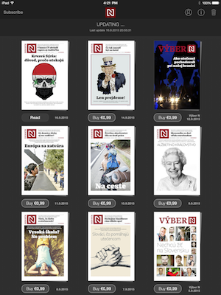
Choose one skin type of the application
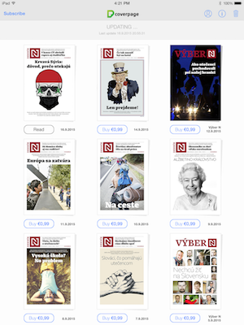
- dark skin
- bright skin

Accent colour
Choose accent colour for your app and provide Hex Color Code. Colour will be used for buttons, text, top bar etc. Natural system colour can be used instead (see examples above).
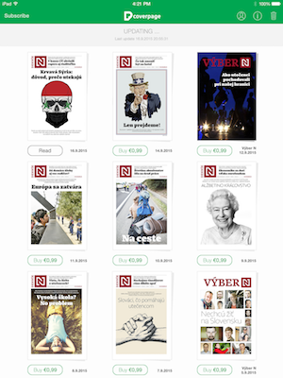
Hex Color Code: #_ _ _ _ _ _
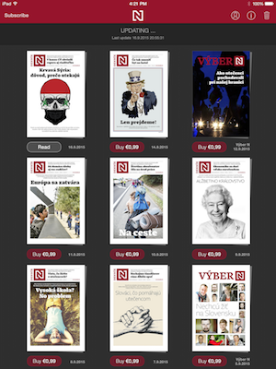
Examples:

App Store text resources

Application name under the icon (max. 12 letters):

Application name in App Store (max. 30 letters):

Application subtitle in App Store (max. 30 letters):

Application description in App Store (max. 4 000 letters):

Category (pick 2 – Primary and secondary):
Books, Business, Education, Entertainment, Finance, Food & Drinks, Games, Health & Fitness, Lifestyle, Magazines & News, Medical, Music, Navigation, News, Photo & Video, Productivity, Reference, Shopping, Social Networking, Sports, Stickers, Travel, Utilities, Weather
Primary:
Secondary:

Key words (max. 100 letters commas included):

Copyright:

Price of application:

Price of one published project:

Price and type of the subscription:

App Review Contact Information:
Name:
Surname:
E-mail address:
Telephone no.:

Information needed for testing the app on your side

UDID (only for iOS devices)
Each iPhone or iPod Touch has a Unique Device Identifier (UDID), which is a sequence of 40 letters and numbers that is specific to your device. The UDID is needed for ad-hoc distribution applications.

Device UDID - How to find UDID

